Minorities and Women In World War II
AP US History Document-Based Question

Evaluate major changes in the attitudes toward and the experiences of women and minorities (World War II (1939-1945).
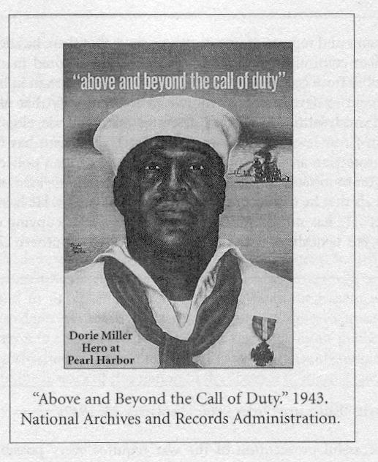
Document 1

Document 2

Brigadier General B. 0. Davis to General Peterson, 9 November 1943 (Brigadier Davis had just completed an inspection of military bases in Massachusetts, New York, New Jersey and Michigan):

“…While there have been an improvement in general conditions, there is still great dissatisfaction and discouragement on the part of the colored people and the soldiers...The Press news items and reports of investigations show that there has been little change in the attitudes of civilian communities in Southern states. The colored man in uniform receives nothing but hostility from community officials.... The colored man in uniform is expected by the War Department to develop a high morale in a community that offers him nothing but humiliation and mistreatment. Military training does not develop a spirit of cheerful acceptance of Jim- Crow laws and customs. The War Department has failed to secure to the colored soldier protection against violence on the part of civilian police and to secure justice in the courts in communities near-by to Southern
stations. In the areas recently inspected, the colored soldier feels that he can secure justice in the civil courts. He has not been set upon by the civilian police. He has not been denied the privilege of occupying empty seats in public buses, street cars, etc. taxicabs to serve him. This is not so in Southern communities....”

Document 3

Franklin D. Roosevelt, "Fireside Chat on the Home Front," October 12, 1942:

“In order to keep stepping up our production, we have had to add millions of workers to the total labor force of the Nation. And as new factories come into operation, we must find additional millions of workers. This presents a formidable problem in the mobilization of manpower. It is not that we do not have enough people in this country to do the job. The problem is to have the right numbers of people in the right place at the right time....

In some communities, employers dislike to employ women. In others they are reluctant to hire Negroes. In still others, older men are not wanted. We can no longer afford to indulge such prejudices or practice.

Document 4

"Women are welders [sic] discuss the production of motor mounts and welded parts in a welding booth at the Inglewood, Calif., plant of North American Aviation, Inc." 1942. National Archives and Records Administration.

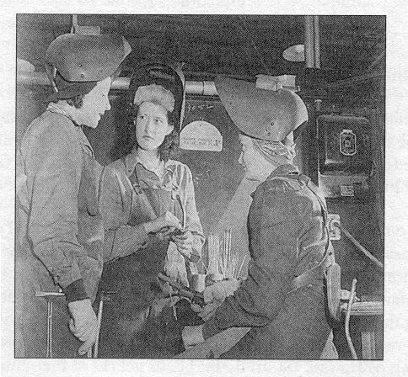

Document 5

