THEATRE SCENIC DESIGN
A SCENIC DESIGNER is the member of the creative team charged with developing the environment used to tell the story of a play, musical, or performing arts piece. Other members of this collaborative team include but are not limited to the costume designer, sound designer, lighting designer, and director.
Scenery provides a playground for the director to use in telling the story of the piece. A scenic designer works with the director in exploring how and why each item — platform, flat or wall, table, chair, cube — is or could be used.
A scenic designer uses many tools to create a set: a visual script analysis, thumbnail sketches, detailed sketches or renderings, and scenic models. Below is a breakdown of one approach to the creative work of scenic design. Not everything works for everyone.

STEP 1: READ AND ANALYZE THE SCRIPT
A scenic designer takes a different approach to reading a script than actors and directors do. A scenic designer does not focus on objectives, motivations, subtext, or tactics of the characters but rather takes interest in the visuals and stated needs of the production. Below is a brief outline of the steps for a scenic designer to break down a script.
First, read the script for enjoyment. Read it all the way through — without stopping. Unlike a novel, theatrical performances are meant to be experienced uninterrupted. When seeing a live performance, the only time the show is interrupted is at intermission. Give yourself plenty of time to read the entire script from beginning to end. Time your bathroom break to when you get to the written intermission break. Do not think about what your specific version of the show might look like. Do not draw anything. Do not take any notes. Just experience what the playwright has written. If working on a musical, try to have the soundtrack to listen to as you read the script.
Second, read the script for sensory and physical needs. The purpose of this step is to identify all of the production’s sensory elements. Break down what the show needs for the story to be told. Use the following categories to organize your thoughts: sets, costumes, lights, sounds, props, colors, imagery, and “other.” Pick one color of highlighter for each category and use a red pen to underline props.
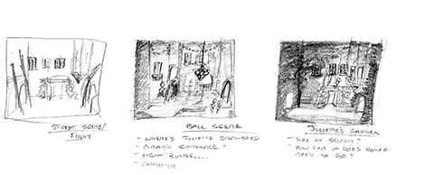

Thumbnail set design sketches for Boston University’s Roméo et Juliette. Photo courtesy of Christopher Dills.
Take your time to mark everything having to do with these categories. The color-coding system helps you to quickly see each element and any repetition in imagery, metaphors, symbols, and colors — which will aid you in exploring how this repetition might affect the production’s story. While color-coding your script, take an opportunity to write notes in the margins. Write anything that comes to mind: things, questions, names of visual artists, etc.
Finally, create a list of what you found. You have created a multicolored script full of notes and scribbled thoughts and observations. Organize this into a clear list. Everything you highlighted or underlined should be categorized as a set need, prop, costume, etc.
As you create these lists, pay attention to where the information comes from. Did it come from the lines spoken by the actors or from the stage directions? Items that come from the spoken lines are more important than those that come from the stage directions. With some exceptions, people associated with the original production (usually, the stage manager) write the stage directions. It is important to know what was done in the original production, but if someone does not speak it onstage, then it does not necessarily reflect the playwright’s original intention or idea. It is most important that the playwright’s intent be the primary focus of what is created and told.

STEP 2: REFINE YOUR IDEAS WITH THUMBNAILS AND ROUGH MODELS
What did you find in your breakdown and analysis of the script? What visuals stood out to you? Why is this story important? What is the best way to tell the story?
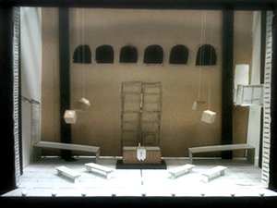
This rough model explores the church scene from Boston University’s Roméo et Juliette. Photo courtesy of Christopher Dills.
Theatre is a visual medium. A scenic designer needs to be able to describe to the creative team what the show might look or feel like. Early in your design work, sketch small, quick drawings of various ideas for the show. These are “thumbnail sketches,” no larger than a few inches across. Each sketch should only take you a few minutes to complete. They do not necessarily relate to each other. Sketch anything that comes to mind and move on to another.
Once you have six to eight thumbnails, identify what you like and what you dislike. What helps you and your collaborators to tell the story the best and provides the best opportunity for the director and actors to succeed and connect with the audience?
Take your favorite thumbnail and construct a three-dimensional rough model, with scale and proportion in mind. Like the thumbnails, this model should be quick and a response to your feelings and reactions. A rough model is usually built in one-quarter-inch scale.
Use construction paper, cardboard, printer paper, cereal boxes, and the backer board of legal pads. Cut the materials with scissors or a hobby knife. Use craft glue, hot glue, or tape to secure the pieces together as needed. Do not think too much about what you are creating. Rip, tear, glue, and repeat as many times as necessary.

STEP 3: COLLABORATE AND REVISE
Design is a team effort. Schedule a design meeting with the creative team. Use the thumbnails and rough model you created to start a conversation about the production. During that meeting, be prepared to alter your sketches and model — in front of everyone. By doing that, you invite everyone into the creation and show that you are open to everyone’s ideas. A good scenic designer recognizes that the best ideas are developed through the input of many.

STEP 4: DRAW AND RENDER
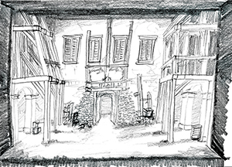
A rendering of a street scene from Boston University’s Roméo et Juliette. Photo courtesy of Christopher Dills.
Drawing can be the scariest part of being a scenic designer. A fear of inadequacy traps many designers. They fear that what they draw will be considered subpar and not what the set will look like. This feeling is normal and healthy, because it inspires us to better ourselves as visual artists. These drawings, sometimes called “renderings,” are communication tools — not exact representations of the scenery. Do not worry about color; draw using shades of gray.

STEP 5: DRAFTING, PLANNING, AND WHITE MODELS
Until now, measurements and dimensions have not been as important as feelings and imagery. Now is the time to make measured plans and draftings. How tall is that door? How wide is that window? Where is the couch located? Items have to be built, and furniture has to be bought or found.
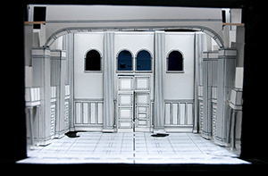
A white model is a very detailed rough model all in white. Photo courtesy of Christopher Dills.
Use your measured plans to flesh out a “white model,” which is a rough model that does not focus on color. You can construct a white model using the same construction materials you used to build the rough model, but you should include as many details of your design as possible — like door molding and window styling — to provide a more complete visual aid of what the final scenic design will look like.
The white model and measured plans are the final opportunity to revise your design before construction begins. Whether you are building your design yourself or it is being built in a professional shop, design changes cost both time and money. When making your white model, it is common to discover opportunities to better your design. You may find yourself making two to three different white models.

STEP 6: FULL-COLOR, SCALE MODEL OR RENDERING
The final step in your design is creating a full-color, scale model or rendering. A rendering is a perspective drawing of what your design will look like. The rendering and the model should include as much detail as the white model — plus color and texture. The model can be built in either one-quarter-inch or half-inch scale. Full-color, scale models and renderings are used as presentation tools. They are perfect to bring to the first rehearsal to show the cast. Having a scale model available for reference during rehearsals will help the director with their blocking and creative work.
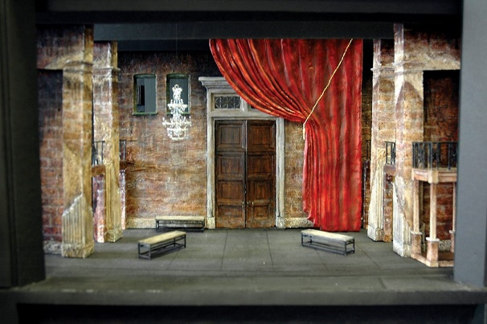
A rendered model for the opening scene of Roméo et Juliette. Photo courtesy of Christopher Dills.

STEP 7: REHEARSALS AND DEVELOPMENT
Just because rehearsals have begun does not mean the scenic designer’s job is finished. Directors and actors will always discover things in rehearsal that no one had anticipated. A scenic designer must be open to such discoveries and be able to adapt their scenic design. These discoveries often provide an additional creative layer to the production you are working on.

STEP 8: TECHNICAL REHEARSALS, OPENING NIGHT, AND PERFORMANCES
The entire vision comes together in the week or two before opening night. What you have spent weeks to months developing is finally built onstage. This is the only time to make sure that everything fits together onstage just as you envisioned in your mind. You should move around the theatre, viewing the set from as many different seats as possible. Does the wall color clash with an actor’s costume? Can the audience see offstage? Do you need to add additional masking? Changes and alterations to improve the production can and should be made as long as time allows. The production is not finished until the curtain rises on opening night.

Teacher’s Name _______________________
Student’s Name ______________________
Date ________________ Period _______
After reading about Theatre Scenic Design, list (in your opinion) the top 10 points that a scenic designer must do or must consider in order to effectively do their job. Explain why you believe teach of them to be an important element. (2 – 3 sentences) If you are handwriting this, you will need to use a separate piece of paper.
1.

2.

3.

4.

5.

6.

7.

8.

9.

10.

